**Whitewater Rafting Site Plan – Guilherme Commarela**

Logo:

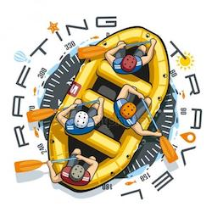

Colors:

primary-color 🡪 green - rgba(11,156.49,1)

secondary color 🡪 gray – rgba(25,31,52,06)

accent1-color 🡪 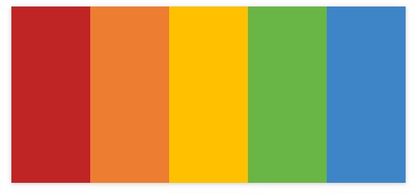 - rgba(255,0,0,0.8)

- rgba(0,0,255,1)

Typography:

Headings 🡪 Aharoni

Body 🡪 Aldhabi

Coolors URL:

<https://coolors.co/palette/8ecae6-219ebc-023047-ffb703-fb8500>

<https://coolors.co/palette/ffbe0b-fb5607-ff006e-8338ec-3a86ff>